110學年度第2學期 開南中學英文科 6/10補救教學學習單
班級: 座號: 姓名:
一、單字 ( 備選單字：將正確英文填入圖片的右方。)
sweat | mirror | butter
rocket | candle | student loan
wing | foreigner | wealth
banner/ couplet | queue | confusing
reservation | text | stress out

中文 | 圖片 |  |  |  |  | 英文
1.學生貸款 | 
2.簡訊 | 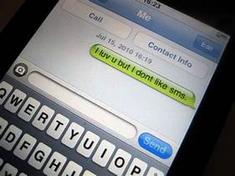
3.流汗 |  | 
4.蠟燭 |  | 
5. 鏡子 |  | 
6. 排隊 |  | 
7. 壓力大 |  |  | 
8. 外國人 |  |  | 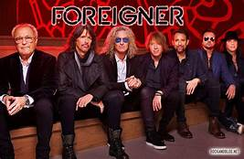
9. 奶油 |  |  | 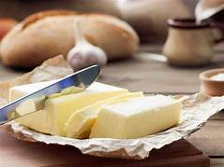
10. 財富 |  |  | 

11. 翅膀 | 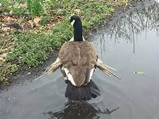
12. 預約 | 
13. 火箭 | 
14. 對聯 | 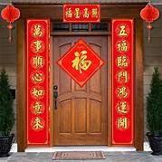
15. 困惑的 | 
二 、看圖說話 (選出符合圖片描述的正確答案)
1. What is the man doing?
(A) He's driving a car  (B) He's planting a tree.  (C) He's picking the leaves. | 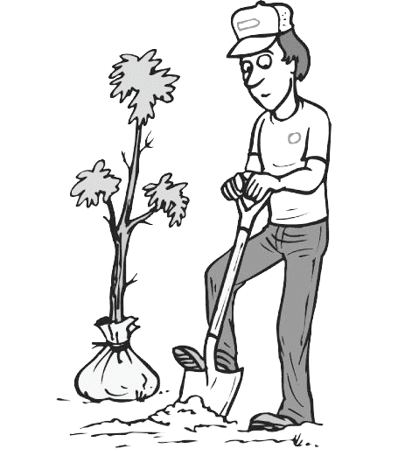
2. . What is Billy doing?
(A) He’s doing his homework.  (B) He’s making himself dinner.  (C) He’s making his bed. | 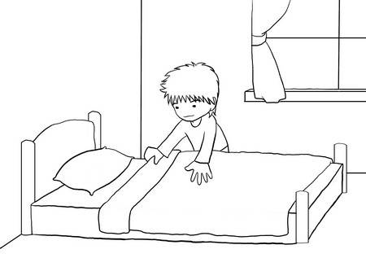
3. What is the man’s profession ?
(A) He is a doctor.  (B) He is a lifeguard.  (C) He is a soldier. | 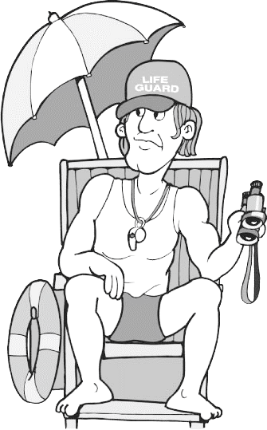
4. What's happening in this picture?
(A) The father is playing with a puppy.  (B) The little girl is playing with a puppy.  (C) The father and the little girl are reading a storybook | 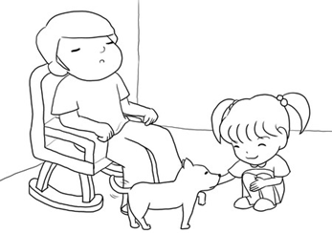
5.Which is true about the picture?
(A) More people like to order toast than sandwiches.
(B) Scrambled eggs are more popular than toast.
(C) Hamburgers are the most popular food.
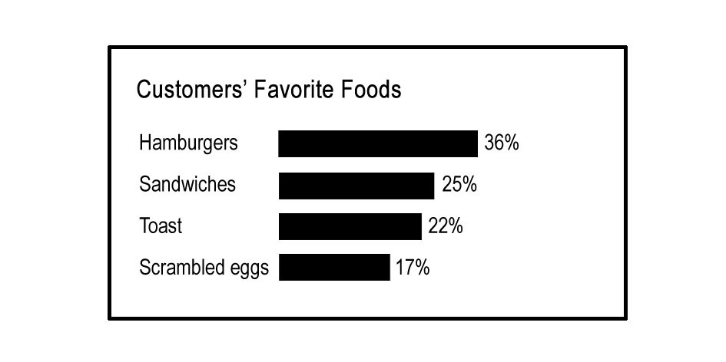
6. How is Mrs. Atkins getting to work today?
(A) She’s taking the bus.  (B) She’s getting in ride in a friend’s car.  (C) She’s driving car. | 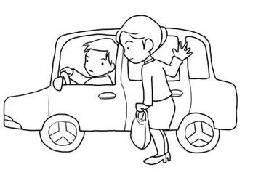

7. . What is Billy doing?
(A) He's doing his homework.  (B) He's making a cake.  (C) He's fixing a car. | 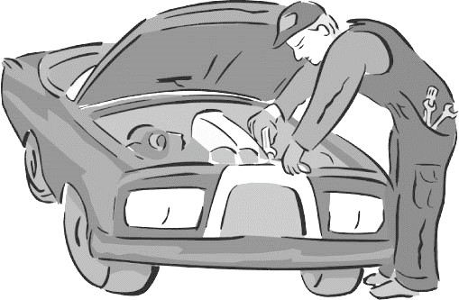
8. What is the man doing?
(A) He’s driving a car.  (B) He’ stuck in traffic.  (C) He’s crossing the street. | 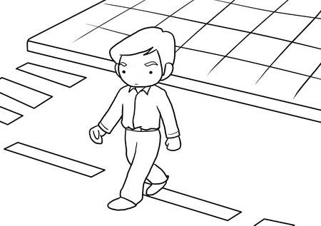
9.Where is Mr. Nelson?
- He's at a gas station.  (B) He's in his car.  (C) He's at home. | 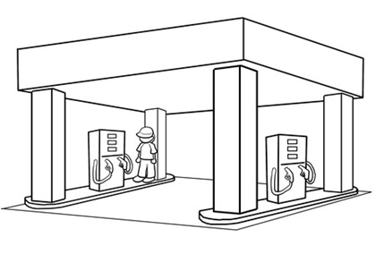
10. What do you think Peter most likely said to Jane as she walked in the door?
(A) Good morning! You're home early!  (B) Good afternoon, dear. Did you have a good day?  (C) Honey, you're home late! You must be tired. | 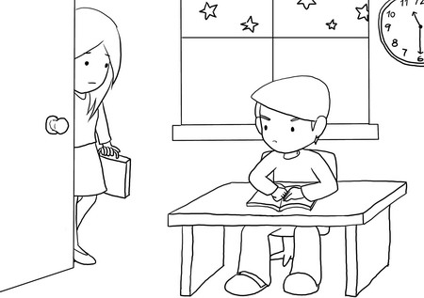
三、 句子配合
從下表找出正確對應之英文句子，並且工整地寫下。
- Don’t cut the line.
- What is this line for?
- First come, first serve.
- I hope you will have ample surplus in the coming year.
- May everything go as planned
- I am making you sweat like that.
- We’re stressed out
- I owe it all to my mother
- You can only get in line when your entire party is here.
- Wake up, you need to make money
1. 不要插隊

________________________________________________________________
2 我們壓力很大

________________________________________________________________

3. 請問這邊在排什麼?

_______________________________________________________________
4. 我讓你汗流浹背

__________________________________________________________________
5. 全歸功於我媽媽

__________________________________________________________________
6. 全都到齊才可排隊

__________________________________________________________________

7. 萬事如意

__________________________________________________________________
8. 先到先招待

__________________________________________________________________
9. 年年有餘

__________________________________________________________________
10. 醒醒了! 你該賺錢.

__________________________________________________________________

請於6/10 (五) 補救教學前完成，並於當日攜帶繳交!

